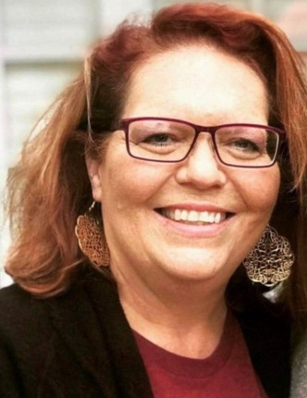**2021 Pamela Horne Memorial   
Nursing Scholarship Application**East Central University  
  
  
Pam served as a RN and nurse manager in several units at Mercy Hospital Ada for 20 years.  She graduated from Ada High School in 1980, where she was an All-State vocalist.  She received her Associate Degree in 1991 from Northern Oklahoma Junior College in Tonkawa.  She was the 2012 March of Dimes Oklahoma Pediatric Nurse of the Year.  Pam mentored hundreds of college nursing students and new graduates in her profession. She brought energy, fun and humor while also being the constant professional. She went above and beyond daily for her patients and co-workers.  She volunteered and served constantly always thinking of others in their time of need. She never missed a Relay for Life event always dancing and enjoying the event with co-workers and cancer survivors. Pam was a true leader in every sense.  This scholarship honors her passion and service to others.    
  
**Application Deadline:  April 2, 2021 l Scholarship Announcement by May 7, 2021**

Full Legal Name: ________________________________________________________  
  
Mailing Address: ________________________________________________________  
  
Email: ____________________________  Cell Phone:  _________________________  
  
Expected Graduation Month: ______________________ Year: 20_________________  
  
Nursing Honors:  ________________________________________________________  
  
______________________________________________________________________  
  
______________________________________________________________________  
  
______________________________________________________________________  
  
______________________________________________________________________  
  
Community Service: _____________________________________________________  
  
______________________________________________________________________  
  
______________________________________________________________________  
  
______________________________________________________________________  
  
**Yes l No (Please circle one)** I am a current full-time in the East Central University undergraduate nursing student program in good academic standing applying for this fall $500 one-time Pamela Sue Horne scholarship.    
  
The scholarship is competitive, and applicants will be evaluated on a combination of college GPA, need, service and essay.  Finalists will be interviewed by the Horne Family to select the scholarship recipient.  
  
***Please attach and submit the following information with the application:***-Current College Transcript  
  
-ECU Nursing Program Acceptance Letter  
  
-Attach a one-page typed essay (500 word max) on why you have chosen the nursing profession, what are your career goals and aspirations after graduation.  Also, describe one significant past or current service experience and what you've gained from the volunteer opportunity to give back to your community.    
  
**Submit completed application along with requested materials by Friday, April 2, 2021 to the following address or, scan and email to** [**todd.essary@mercy.net**](mailto:todd.essary@mercy.net) **for committee review and selection.**   
  
Mailing address: The Pamela Horne Nursing Scholarship, Mercy Foundation, 430 N. Monte Vista, Ada, OK 74820.   
  
Scholarship announcement by Friday, May 7, 2021.