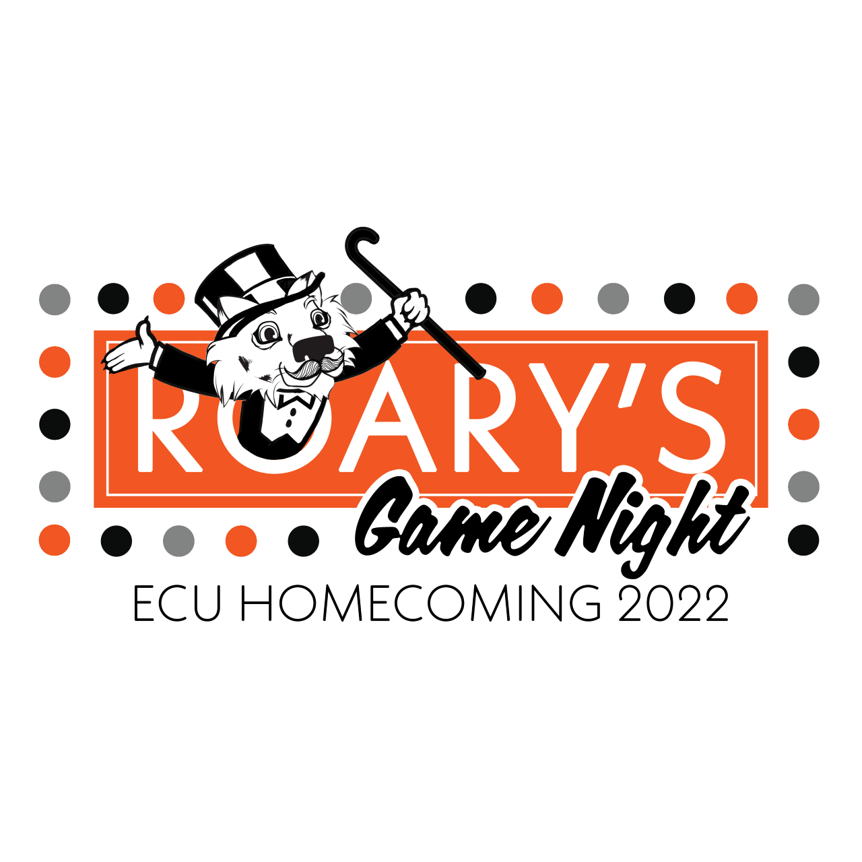
GENERAL INFORMATION
HOMECOMING 2022
ROARY’S GAME NIGHT

To participate in any Homecoming events, your organization must be a fully recognized organization at East Central University & the Office of Campus Involvement.
Contest results and Division Champion winners will be announced DURING the football game on Saturday, October 22nd 2022, as well as posted updates throughout the week on the ECU social media.

Decisions of The Office of Campus Involvement are FINAL.

COURT EVENTS

East Central University provides an opportunity for student representatives to compete and possibly be selected to the Homecoming Court. This selection is implemented through an interview and voting process. Court candidates need not be “couples”, as candidates are selected for their representation of the greater campus community. Please refer to Court Packet for details.

ECU Alumni Activities
HOMECOMING 2022
ROARY’S GAME NIGHT

Please encourage ECU alumni to return to this year's festivities. Homecoming is not only for the students of the present, but also of the past. Homecoming allows your alumni the opportunity to remember their time here, talk with old friends, and also meet the new members of your organizations. Remember to include your alumni in this year's Homecoming festivities. More information is available @ecok.edu/alumni.

Earning Championship Points
HOMECOMING 2022
ROARY’S GAME NIGHT

Championship points are awarded in each division as follows:

Banner Contest
Paint Dodgeball
Penny War Challenge (winner takes all)
Poster Contest (which group makes the most posters)
Parade - Float
Tiger Tailgate (by vote of tailgate attendees)

1st Place 200 points
2nd Place 150 points
3rd Place 100 points

Participation Points!
(applies only to organizations that do not place in that event)

- Volleyball game (at least 10 members) …………………………………..100 points
- Pep Rally & Bonfire Participation (at least 5 members) ……...…………….100 points
- Soccer game (at least 10 members) ……….……………………………….50 points
- Parade Participation…………………………………………………………50 points
- Tiger Tailgate Participation(must include tent, table, activity, orange décor, and some type of tailgating finger food) ………………………………………………50 points
***This does NOT include Saturday’s Athletic Events***

Special Projects
25 points per door décor can be earned by any group at the discretion of the Office of Campus Involvement. Must have permission from the correlating office before decorating. Not allowed more than 4 doors! If you sign up for a project and do not complete it, 50 points will be deducted from your organization.
HOMECOMING 2022
ROARY’S GAME NIGHT

Events Points/Possible

Monday , September 26

General Meeting Attendance- 5:00 p.m. ____/50

Thursday, September 29
Court Mandatory Meeting 7pm and Court Application Due 7pm ____/50

Thursday, September 29
ALL FORMS DUE to the Office of Campus Involvement (University Center 152) by 5 pm N/A
Monday Oct 3rd
Court interviews
Freshman- 9:00 NA
Sophomore- 10:00
Junior- 11:00
Senior-12:00
Parade Entry Deadline ____/50

Wednesday, OCT 12th
Banners Due to the Office of Campus Involvement (University Center 152) by 5pm N/A

Monday, OCT 17th
Banner Judging 8am-5pm ______/100
Paint Dodgeball 6:00 P.M. _____/100

Tuesday. OCT 18th
Penny wars 8:00 a.m.- 5:00 p.m.
/50

Wednesday, OCT 19th
Court Voting 10am-5pm N/A
Poster making 6:00- 8:00 P.M. ____ /100

Thursday, OCT 20th
Soccer 3:00 p.m. _______/50
Volleyball 7p.m. ______/100
Friday, OCT 21st
Pep Rally/Bonfire _____/100
Saturday, OCT 22nd

Parade Float /200
Parade Marching Unit/Walkers N/A
Tiger Tailgate ______/50

Other

Special project / 100

TOTAL ____/1100
HOMECOMING 2022
ROARY’S GAME NIGHT
Registration packet
Fill out this form and attach all forms (completed) with the paw print to this page and turn in to the Office of Campus Involvement.

Club/Organization name:

President/Advisor name:

Contact number:

Select the Homecoming events you will be competing in:
__________Banner Contest
__________Penny War Challenge (winner takes all)
__________Parade - Float
If pairing with another club or org please list below
________________________________________
__________Poster Contest (which group makes the most posters)
__________Paint Dodgeball (must have 6 for your team)
List the name of the 6 players below
1.
2.
3.
4.
5.
6.
__________Tiger Tailgate (by vote of tailgate attendees)
If pairing with another club or org please list below
________________________________________
__________Volleyball game (at least 10 members)
__________Soccer game (at least 10 members)
__________Pep Rally & Bonfire Participation (at least 5 members)

Banner Contest
HOMECOMING 2022
ROARY’S GAME NIGHT

Dry Banners Due:

October 12th

The Office of Campus Involvement

Displayed in University Center

- Banner size MUST be a twin bed sheet and must be made of cloth.

- Your banner will hang vertically (Long side up and down).

- Banner must display your 12" by 12" number in the lower right corner (given after registration)

- No glitter will be allowed; use of glitter may result in disqualification.

- One of the colors used on the banner must be orange (5 points).

- The cheer or slogan written on the banner must use the words "Tiger" OR "ECU or East Central University" AND have organization identification (5points).

- Entry forms must be turned in to The Office of Campus Involvement (University Center 152) by 5 pm, September 29th

- Banners must be turned in to The Office of Campus Involvement, DRY, no later than OCTOBER 12th by 5 pm to qualify for judging. You are encouraged to submit your entries earlier.

- Banners will be judged in the following areas:
  - Adhering to Homecoming Theme 30 pts.
  - Originality/Creativity 30 pts.
  - Overall Impression 25 pts.
  - Adhering to Rules (above) 15 pts.
Total 100 pts.

- Banner designers and artists must be current East Central University students.

- The decision of the judges is FINAL.

- Winners will be announced at the Pep Rally.

Banner Entry Form
HOMECOMING 2022
ROARY’S GAME NIGHT

Application Deadline September 29th, 2022 by 5:00pm
Banner Turn in Due Date: October 12th by 5:00pm

All Applications and Banners are due to
The Office of Campus Involvement: University Center 152

**PLEASE READ**

___Twin Sheet (Do not use double, regular, queen, or king sized sheet)
___Your banner will hang vertically (Long side up and down).
___Banner must display your 12" by 12" number in the lower right corner

**If your banner does not meet these three requirements, your entry will be disqualified**

Your organization has the option to hang your banner at the field and removing it at the end of the game. If you have any questions, please call (580)-559-5207.

Student Organization ________________________________________

Signature of Organization President_____________________________

Phone Number ____________ Email _______________________

Winners will be announced at Pep Rally!

BANNER#_______
Banner Judging Form
HOMECOMING 2022
ROARY’S GAME NIGHT

Banner #: ______________________________________________ Judge: _________________
Division: Two categories will be judged:
❑ Fraternities and Sororities ❑ Student Clubs/Organizations

Please consider these requirements while judging:
Must be on a twin size sheet and hang vertically.

Areas of Judging: Total Possible Points: 100
- Adherence to the Homecoming theme, including originality and creativity.
Theme 30 pts _____________
- Tiger spirit, use of “ECU or East Central University” and “Tigers”, use of the color orange, overall community appeal.
Automatic 5 points for orange & 5 points for use of both terms

Tiger spirit 30 pts _____________
- Craftsmanship, design, attractiveness---including colors, neatness, and presentation.
Craftsmanship/ Originality/Overall effort 20 pts _____________
- Overall presentation of the banner
Overall Appearance 20 pts _____________
Grand Total_______ (100 points maximum)

Door Décor Contest Entry Form
Homecoming 2022
ROARY’S GAME NIGHT

Artist(s) Information
First Name:
Last Name:
Main Phone:
Alt. Phone:
Email:
Student ID:
Organization:
Doors and offices decorated

- Contest participants must be currently enrolled students at East Central University.
- Please see the Participation Agreement on the following page for more information.

Contest Participation Agreement

Thank you for your application to participate in the door décor contest! To ensure we maintain the integrity of the mission at East Central, please read our participation policy below, initial each, sign, and date.
 | Initial here: | Equity Statement – It is the policy of the Office of Campus Involvement to provide equal opportunities for participation without regard to age, disability, ethnicity, gender, immigration status, economic status, national origin, race, religion, or sexual orientation.
 | Initial here: | Content – All art displays must be reflective of the spirit of Homecoming, as well as this year’s theme. Any art work deemed not to be within these guidelines will be removed from the contest entry.
 | Initial here: | Chalk and other art supplies – The use of permanent markers, paints, or oil based chalks are prohibited on all doors and school facilities.
 | Initial here: | Participants – Single entries are accepted and encouraged. If you would like to work in a group, there may be no more than two people per “team.” If any participant(s) violate this policy, their entry will not be considered.
 | Initial here: | Deadlines – All entries must be completed by October 17th .
I have read and understood the policies above and I agree to abide by this agreement.
If you are signing for a group, you agree to share this information with your partner.
Signature:
Date:

- Please submit both pages, signed and dated to the Office of Campus Involvement, University Center ( Room 152).
- If you have any questions or concerns, please contact our office by email: micaall1@ecok.edu or phone: 580-559-5207.
Thank you for applying for this year’s door decor contest!

Door Décor Judging Form
HOMECOMING 2022
ROARY’S GAME NIGHT

Square #: _________________ Judge: _______________________

Please consider the following requirements while judging:

Areas of Judging Possible Points

1.) Creative 5 pts_____________
Adherence to the Homecoming theme including Originality and Creativity.

2.) Use of Color 5 pts_____________
The more colors the better.

3.) Design . 5 pts_____________
Look for quality presentation and overall effect.

4.) Overall Impression 5 pts_____________
How good is the overall image? Does is portray a good message?

5.) Character
Did you work well with the faculty/staff on decorating the door? 5pts ______________

Grand Total: _________________

Parade
HOMECOMING 2022
ROARY’S GAME NIGHT
Saturday, October 22 2022 Parade Start 11:00 AM

- Car entries are encouraged but will NOT be judged.
- A first place will be awarded in each division. There will not be an overall winner awarded.
- The proper parade unit entry form must be turned in to The Office of Campus Involvement (University Center 152), on OCT 3rd, 2022
- Professional help of any kind in the planning or construction of the float or marching unit will result in automatic disqualification.
- No float may be higher than 12 feet.
- Each float must be able to move forward at a rate of 5 mph.
- Judging of Floats will be done in these areas:

  - Adhering to Homecoming Theme 50 pts.
  - Tiger Spirit 75 pts.
  - Craftsmanship/Originality 40 pts.
  - Walkers 35 pts.
Total 200 pts.

- The parade will start at 11:00 a.m. All groups entering the competition must check-in at 314 W 12th St. parking lot at their assigned time. Late check-ins will result in a 15-point penalty. Remember!! Check-ins and line up for the parade will take place at the assigned times on Saturday October 22nd. All entries should be lined up and ready to go at their assigned time.
- Absolutely No Day of Parade Entries!!!
- All units being judged in the parade must slow down but not stop while passing the judges' and maintain a 50-yard distance from the unit in front of them.
- Candy, gum, etc., may NOT be thrown from any floats or cars. Candy may be HANDED out from walking parade participants ONLY.
- Floats should be decorated on both sides.

Parade Entry Form
HOMECOMING 2022
ROARY’S GAME NIGHT
Parade Registration- one entry per page

Saturday, October 22, 2022 Parade Start 11:00 AM
Entry Deadline: October 3rd, 2022

- Registration Information
Organization: _____________________________________________________________________
Contact Person: ___________________________________________________________________
Address: _________________________________________________________________________
E-Mail Address: _____________________________Phone: ________________________________
- Parade Script
Each entry will be announced at the grand stand along the parade route according to the announcer’s script. In the space below please list the information you would like announced about your organization and parade entry. (We ask that you please give any information concerning upcoming events, community service, queen biography, advisor, etc. that you would like to be announced by the emcee.)
______________________________________________________________________________________________________________________________________________________________________________________________________________________________________________________________________________________________________________________________________________________________________________________________________________________________________________________________________________________________________________________________________________________________________________________________________________________________________________________

- Entry Description (check one)
Float (Competition)
Float (Non-Competition)
Decorated Car or Truck, (Fire Truck)
King/Queen Candidate
Marching Band
Walkers_____ # of People (page continued)
- Parade Line Up Locations
Parade Order will be posted on the ECU ( ecok.edu) website OCT 7th
TYPE OF ENTRY: | LINE-UP TIME: | WHERE:
Floats- trailer pulled by vehicle. | 10:00am | 12th & Stockton intersection
Decorated Car or Truck | 10:00am | 12th & Stockton intersection
**King/Queen Candidates | 10:30am | 12th & Stockton intersection
Marching Bands | 10:30 am | 12th & Stockton intersection
Walkers | 10:30 am | 12th & Stockton intersection
** King/Queen Candidates are automatically entered. Candidates are responsible for obtaining their car, driver, and flowers.

- Candy
Candy is permitted. However, candy can only be given or handed out by a “walker”. Candy may not be thrown from a float/truck/car or any motor vehicle. Please observe the parade audience and your surroundings to ensure everyone’s safety. Thank you!

- Float Details
- Organizations are required to submit float plans/ designs/ sketches in the Office of Campus Involvement, University Center 152 by 5:00pm on OCT 7th

Construction:
It is the understanding of the organization that with this entry we assume complete responsibility for all materials, tools, equipment, and other items of value in the building in which our entry is being constructed, as well as the return of these items, if borrowed. We also assume the responsibility of the orderly conduct of all personnel on the construction locations. Furthermore, it is fully understood that all activities concerning the parade are considered to be University functions and ALCOHOL IS STRICTLY PROHIBITED.

Parade:
It is fully understood that East Central University is not responsible for any damages to personal property (Cars, Trucks, Trailers, etc.). We assume responsibility for any personal injury that may occur. Reminder: If you have horses please bag them for the parade.

Signature of Contact Person E-Mail Daytime Phone Number

QUESTIONS? Contact: micaall1@ecok.edu, University Center 152 , or 580-559-5207

Parade Judging Form
HOMECOMING 2022
ROARY’S GAME NIGHT

Entry Name: ______________________________________________ Judge Number: _______
Division: Three categories will be judged
❑East Central University ❑ Community
Description: (check all that apply)
❑ King/Queen Candidate ❑Royal Court ❑Motorcycles ❑ Marching Band
❑Fraternity & Sorority ❑Walkers ❑Float ❑Performing Group
❑Decorated Truck ❑Color Guard ❑Drill Team ❑Decorated Car
❑Vehicle(s) (antique) ❑Car w/rider ❑Commercial ❑Other ______________

Areas of Judging: Total Possible Points: 200
- Adherence to the Homecoming theme, including originality and creativity.
Theme 50 pts _____________
- Tiger spirit, including but not limited to enthusiasm and spirit during the parade and community appeal.
Tiger spirit 75 pts _____________
- Craftsmanship, including design, safety, appearance of materials and sturdiness, etc., and attractiveness, including colors, neatness, shapes, and presentation.
Craftsmanship/ Originality/Difficulty/Overall effort 40 pts _____________
- Overall presentation of the float (including but not limited to participation of individuals representing the group and sportsmanship).
Appearance/Operation during parade 35 pts _____________
Grand Total_______ (200 points maximum)

