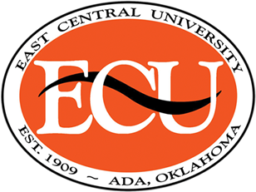
GRACE HYDER RICHMOND AWARD
Award Guidelines:
- Must be a graduating Human Development Hospitality and Food Science Major.
- Submit the following information by going to the ECU web site. Look for scholarships, Human Development Hospitality and Food Science Department. Click current student, look for Human Development Hospitality and Food Science Dept. and click on the Grace Hyder Award. If you have any questions please call or e-mail Darcy Tessman at (580-559-5746/Dtessman@ecok.edu) or Jan Long at (580-399-4771 Jmlong@ecok.edu).
Information may be in the format of a vita or resume as listed below with attachments:
• Current and cumulative grade point average.
• Club membership, extracurricular activities, offices held, and professional memberships.
• Contributions to the ECU Human Development Hospitality and Food Science Department.
• Future professional plans.
• Civic/Community service, employment service.
• Awards/honors
• Financial need
3. Applications will be reviewed by the Human Development, Hospitality and Food Science faculty.
4. Award will be given at the School of Education Scholarship Ceremony- March 2021.
5. Deadline for submission – February 1, 2021. Application may be submitted to dtessman@ecok.edu or jmlong@ecok.edu.

