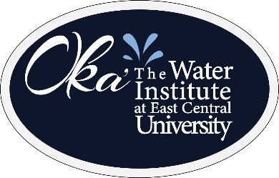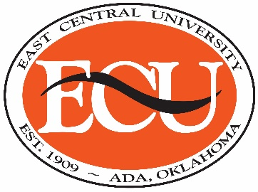 **FOR IMMEDIATE RELEASE:**

**Thursday, August 26, 2021**

**Contact:** Oka’ the Water Institute

at East Central University

580-559-5151

**Oka’ gears up for annual Water Sustainability Conference**

*By REANNA ANDERSON*

ADA – Oka’ The Water Institute at East Central University is gearing up for its sixth annual Sustainability Conference on September 21-22.

The Oka’ Institute is committed to providing practical water solutions for all Oklahomans. Guest speakers from across the state and nation will present on a wide variety of topics throughout the conference.

“We talk about quality and quantity, but we don’t often talk about the value of water,” said Susan Paddack, executive director of the Oka’ Institute. “When you think about water, it is either an economic stimulator or it is a limiter. We cannot grow or prosper as a state or rural communities and water districts if we don’t have a sustainable water future.”

The sustainability conference focuses on water as an economic driver, the importance of soil health, and policies that will ensure key water resources for Oklahoma’s future.

While traditionally hosted on ECU’s campus, the conference will take place virtually this year to provide a safe academic platform for participants. The virtual format will also broaden the reach of Oka’s message. In like manner, more speakers from more locations across Oklahoma and other states can present virtually.

The roster of scheduled speakers for the conference includes a diverse group of professionals. The line-up this year features presentations by researchers and scientists, water-related business leaders and lawmakers. Gov. Bill Anoatubby of the Chickasaw Nation will provide the keynote address, highlighting the conference agenda.

The cost to attend the virtual Sustainability Conference is $50 for a one-day pass and $90 for the entire conference. The registration form and agenda are now available on the Oka’ Institute’s website at www.okainstitute.org.

**(more)**

**Continued from Page 1**

Following is a complete list of expert presenters for the 2021 Sustainability Conference.

**Tuesday, September 21 (Morning)**

• Dr. Katricia Pierson, President, East Central University

• Ken Wagner, Secretary of Energy and Environment, State of Oklahoma

• Dr. Barney Austin, President and CEO, Aqua Strategies

• Duane Smith, Duane Smith & Associates

• Dr. Sharon Megdal, Director, Water Resources Research Center, University of Arizona

• Gov. Bill Anoatubby, The Chickasaw Nation (Keynote Speaker)

**Tuesday, September 21 (Afternoon)**

• Jimmy Emmons, Soil Health Mentoring Coordinator, Oklahoma Conservation Commission

• Dr. Eileen Kladivko, Professor, Agronomy Department, Purdue University

• Lisa Holscher, Director, Indiana Conservation Cropping Systems Initiative

• Dr. Jessica Brumley, Asst. Professor of Biological & Environmental Sciences, East Central University

• Kevin Blackwood, Field Research Coordinator, Oka’ the Water Institute at East Central University; Adjunct Professor, East Central University

• Dr. Randall Ross, Director, RSKERC Groundwater Technical Support Center, USEPA/ORD/CESER/TSCD

• Josh Gaskamp, Wildlife and Range Consultant, Technical Consultant Manager, Noble Research Institute

**Wednesday, September 22 (Morning)**

• Richard Brontoli, Executive Director, Red River Valley Association

• Julie Cunningham, Executive Director, Oklahoma Water Resources Board

• Scott Thompson, Executive Director, Oklahoma Department of Environmental Quality

• Trey Lam, Executive Director, Oklahoma Conservation Commission

• Brandon Bowman, Programs Manager, Oklahoma Rural Water Association

• Dr. Hank Jenkins-Smith, Director, National Institute for Risk & Resilience, University of Oklahoma

• Dr. Carol Silva, Director, National Institute for Risk & Resilience, University of Oklahoma

**(more)**

**Continued from Page 2**

• Senator Frank Simpson, Oklahoma State Senator, District 14, Assistant Majority Floor Leader

• Senator Chris Kidd, Oklahoma State Senator, District 31

• Representative Ronny Johns, Oklahoma House of Representatives, District 25

**Wednesday, September 22 (Afternoon)**

• Dr. Jason Vogel, Director, Oklahoma Water Survey, University of Oklahoma

• Shana Mashburn, Hydrologic Studies Chief, US Geological Survey

• Dr. Christine Pappas, Professor, Department Chair, Politics, Law and Society, East Central University

• Dr. Leah Dudley Assistant Professor, Biological & Environmental Studies, East Central University

• Gary O’Neill, OK NRCS State Conservationist, US Department of Agriculture-Natural Resources Conservation

• Stephen Eoff, Vice President, Jack Tyler Engineering Incorporated

• Kent Foster, Vice-President of Operations-Business Development, CNI Manufacturing

• Susan Paddack, Executive Director, Oka’ the Water Institute at East Central University

**-ECU-**