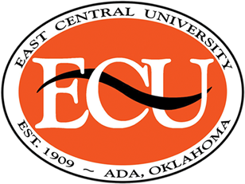
Trease Layton Scholarship
Human Development, Hospitality and Food Science Department

The Trease Layton Scholarship will be awarded each year to an incoming freshman who plans to major in Family and Consumer Sciences at ECU.
Options:
Human Development, Hospitality and Food Science General
Design Buying and Apparel Management
Food Science
Hospitality and Event Management

Guidelines:
- The student shows evidence of majoring in an area of Family and Consumer Sciences and pursuing a career within the field.
- The student has been active in the local Family Consumer Sciences department, and FCCLA or 4-H in high school.
- The student maintains a 3.0 or above GPA.
- The student shows financial need.
- The student lists 3 references (including address and phone number).

HHFS 2021  Scholarship Application  Trease Layton Scholarship | Email Due February 1

Contact Information
Name
Cell Phone
E-Mail Address
What year in school are you?
What is your grade point
What school do you attend? Advisor name and phone number

Why would you be the best candidate for any of these scholarships. Please discuss any hardships or financial needs that has made it hard for you to come to school .

Previous Volunteer Experience

Summarize your previous volunteer experience.

Please include a copy of your transcript and resume.

**All interested individuals are required to complete the scholarship application and email to Mrs. Jan Long jmlong@ecok.edu or Dr. Darcy Tessman dtessman@ecok.edu Human Development, Hospitality and Food Science Department, East Central University Ada, OK 74820 or Email by February 1, 2021 for the 2021-2022 term.

