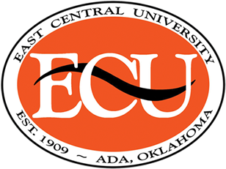
Watson Family Centennial
Human Development Hospitality and Food Science Scholarship
Due date February 1, 2021

Scholarship Guidelines:
- Currently enrolled as an HHFS Education major at East Central University.
- Have completed 35-89 University hours (classification Sophomore/Junior).
- Have a 2.8 or higher GPA in all college work completed.
- Submit the following:
  - Copy of current transcript
  - Include a copy of the following: Resume, overall grade point, HHFS major/pursuing, work experience, scholastic accomplishments, organizational and services activities, statement of need, career goals in the field of Human Development Hospitality and Food Science.

Submit Application to:
Darcy Tessman: dtessman@ecok.edu
Or
Jan Long: jmlong@ecok.edu

