How to Register for the TEAS® Assessment

1. Create a New Account

If you are not a current user on www.atitesting.com, you must create a new account to access the student portal or to make a purchase from ATI's online store. Follow the steps below to create a new account.



From the atitesting.com home page, click **Create Account**.

The Sign In Info page displays.

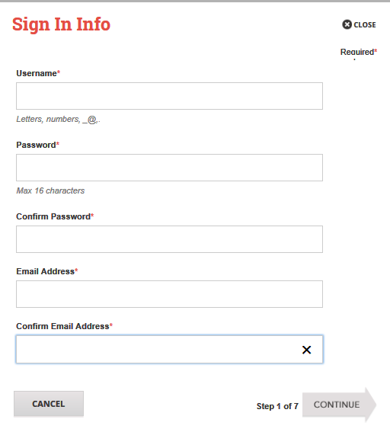

On the Sign In Info page, enter the account information that you will use to sign into your account or to recover your account.

You must enter valid information into all the fields on this screen before you can proceed.

If your entry is not accepted, an error message similar to the one pictured below will display.



Reenter your information. When your entry is accepted, the message will disappear.

After you have entered all your account information, click **Continue** to go to the Security Questions page.

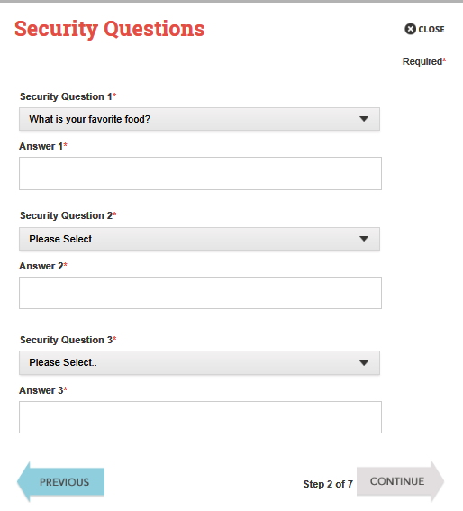

On the Security Questions page, select three different security questions, one from each list and enter your answer for each. Be sure to record your questions and answers for your future reference, in case you need to recover your account, or you cannot remember your password.

Click **Continue** to enter your personal information.

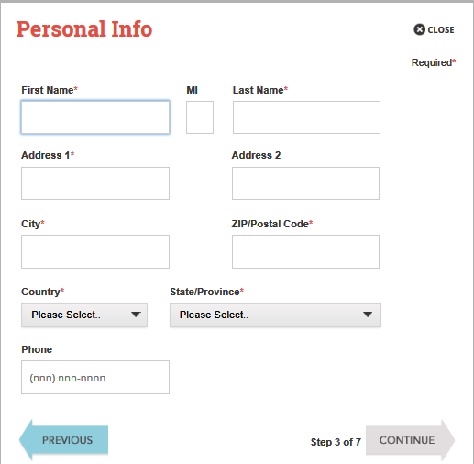

On the Personal Info page, enter your contact information. The following fields are required:

* First Name
* Last Name
* Address 1
* City
* ZIP/Postal Code
* Country
* State/Province

Click **Continue** to enter your Institution information.

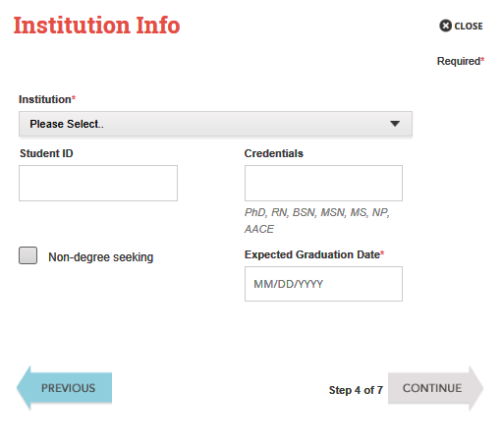

On the Institution Info page, select an Institution from the list and if you are seeking a degree, enter a date in *Expected Graduation Date*. All other fields are optional.

Click **Continue** to enter your Demographic Info.

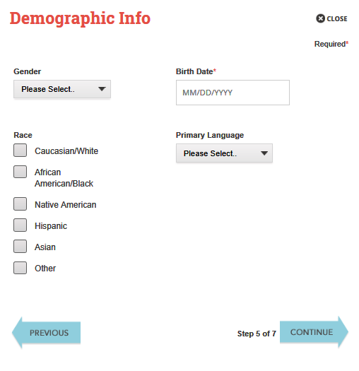

On the Demographic Info page, enter your *Gender*, *Birth Date*, *Race*, and *Primary Language* information. Only *Birth Date* is required.

Click **Continue** to go to Subscription, Updates & Notes.

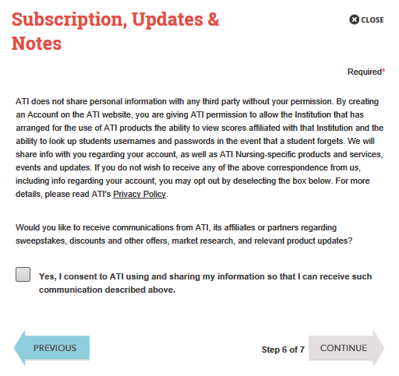

On the Subscription, Updates & Notes page, read the Subscription, Updates & Notes information.

If you agree to allow ATI to share your information under the terms presented on this screen, select the **Yes, I consent** check box.

Click **Continue** to go to User Terms and Conditions.

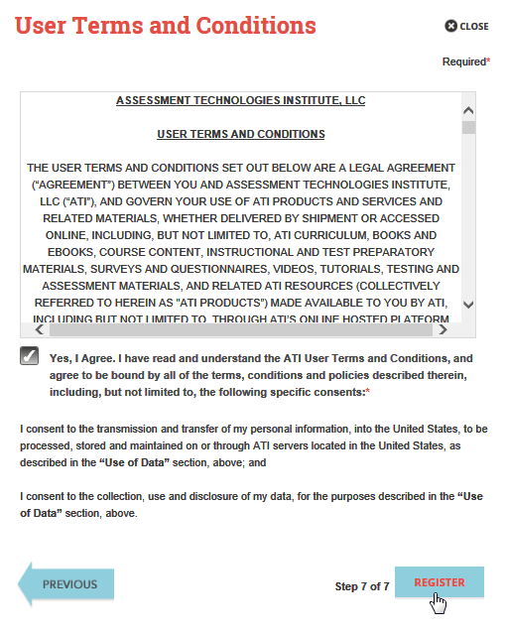

Click **Register** when you are finished creating your account.

Click **Previous** if you want to change any of the information you have entered for your new account.

On the User Terms and Conditions page, read the information under User Terms and Conditions.

Then select the **Yes, I Agree** check box to acknowledge that you have read the ATI User Terms and Conditions and agree to be bound by them.

You can now register for the TEAS® Assessment through our Online Store.

# 2. Sign on to your Account



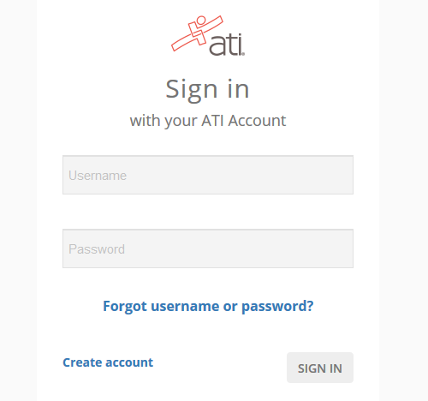

The Sign On window displays and your new Username is filled in for you. Enter your Password and click **GO** to launch the Student Home page.

Then, from the Student Home page, click **Online Store** in the upper right corner. The ATI Store page displays.



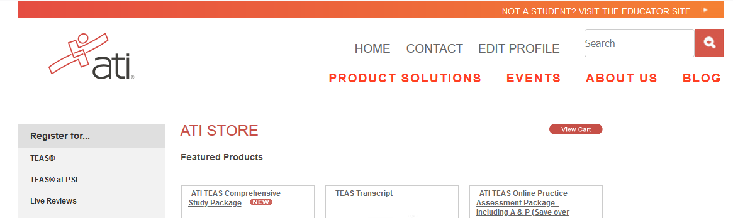

In the *Register for* column, click **TEAS®**. The Registration page displays.

Go to **STEP 2: Register for a TEAS Session** to continue.

1. Register for a TEAS Session

Select a *Program Type*, based on your anticipated area of study:

* TEAS for Nursing Students
* TEAS for Allied Health

From the *Country*, *State* and *City* lists, select the location where you want to sit for the assessment and then click **Next**. The Browse Sessions page displays.

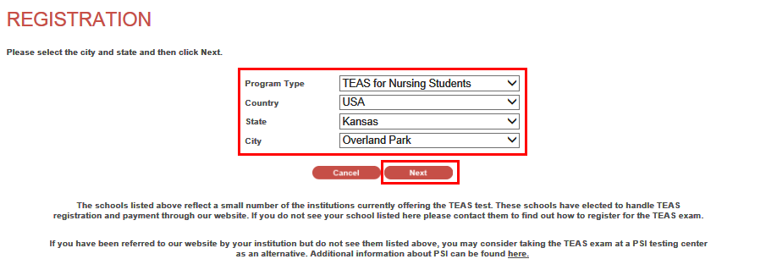

Do one of the following to register for a session:

* Click the **Register** button associated with the session for which you are registering.
* Click the **Learn More** button to open the Product Details window to view details about the session.

Note: If you don’t see a suitable location, you can expand your search by selecting All for the City and/or State.

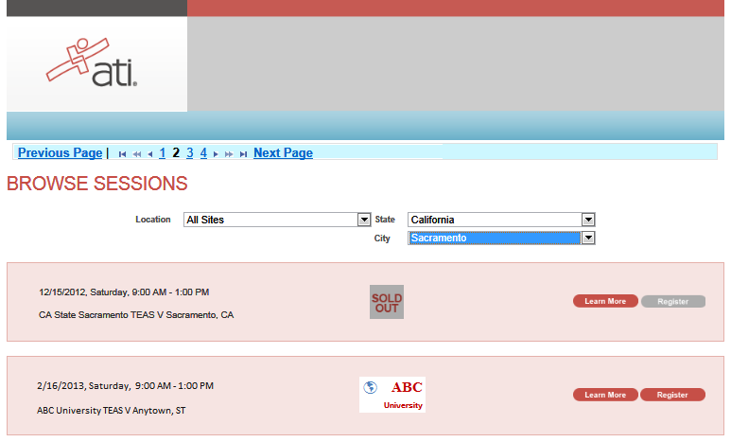

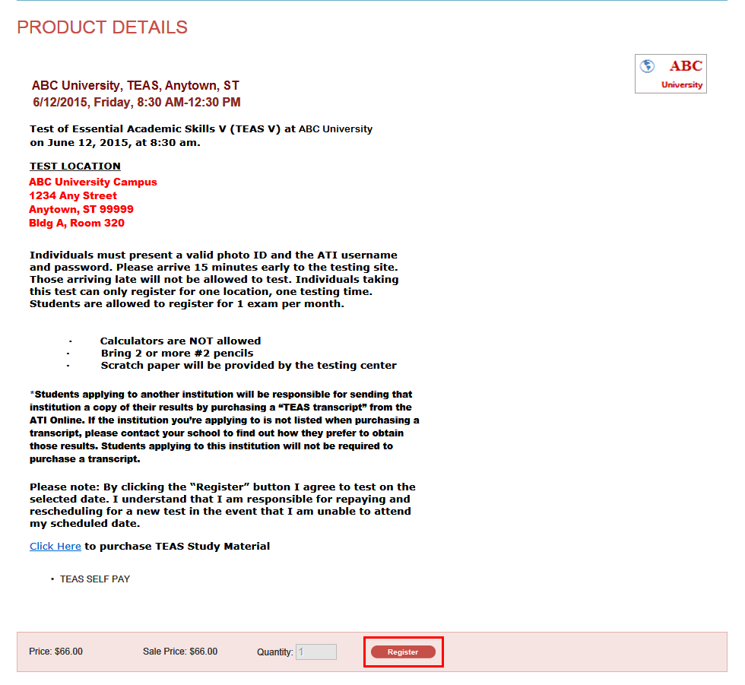

* If you clicked **Register**, skip to the next window.
* If you clicked **Learn More**, you opened this Product Details window. Review the information and then click **Register** to add this session to your online shopping cart or click the back button to go back to your Browse Sessions list.

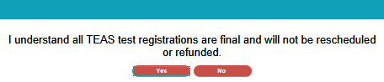

After you click **Register**, this window displays:

Click **Yes** to continue. Your Shopping Cart displays.

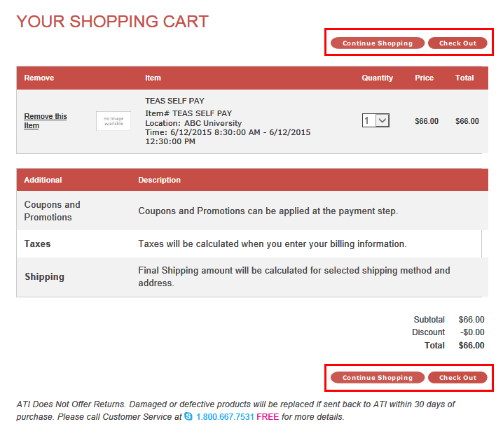

Review the information on the screen. At this point, you have the following options:

* If all the information is correct and you do not want to purchase additional items, click **Check Out**.
* If you want to make additional purchases, click **Continue Shopping** to return to the Online Store.

Note: Supporting TEAS items, such as study aids and extra transcripts, are available from the ATI Online Store. At the Online Store home page, enter TEAS in the *Search* field and then click Go to display all TEAS-related items.

* If you do not want to purchase the designated assessment, click **Remove this Item**. The session is removed from your Shopping Cart. Click **Continue Shopping** to return to the Online Store. Go back to choose a different TEAS Assessment session.
* IMPORTANT:   
  ATI does not offer refunds. Damaged or defective products will be replaced if sent back to ATI within 30 days of purchase. Please call Customer Service at 1.800.667.7531 for more details.

# 4. Check Out and Pay

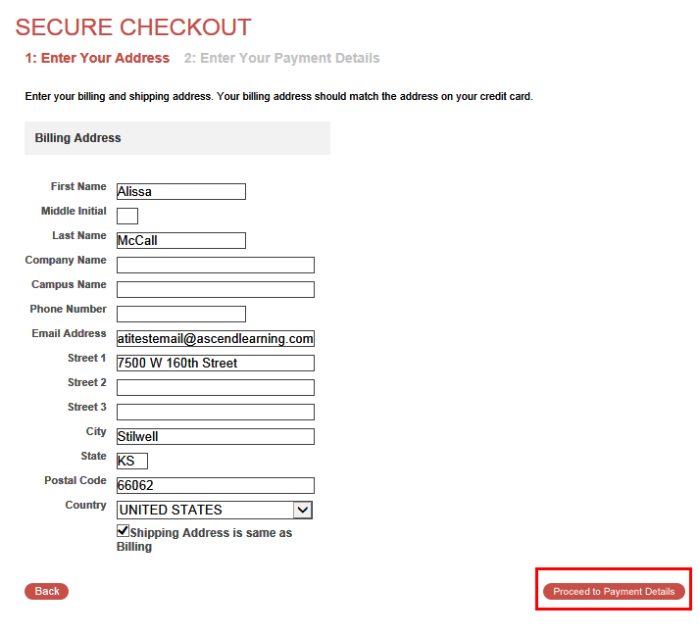

Enter/confirm your mailing address and provide any additional information and then click **Proceed to Payment Details**. The Secure Checkout: Payment Details screen displays.

Note: If any required information has not been filled in, you will be prompted to provide the information before you are allowed to continue

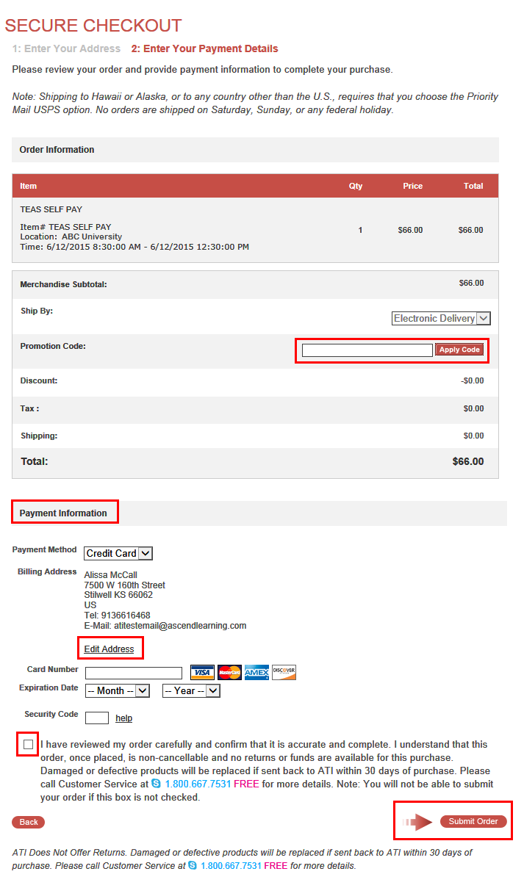

* In the *Payment Information* section, enter your credit card information.
* Check your address information and click **Edit Address** to change the billing information for your order.
* Read the information to the right of the check box. Then, select the check box to verify that your order is correct and that you have read and agree to the terms of your purchase.
* Click **Submit Order**.

If you have a Promotion Code, enter it into the Promotion Code field and then click **Apply Code**.

# Go back to the top

After you click **Submit Order**, your Customer Receipt displays. Your receipt includes any additional instructions for your assessment. Your receipt will also be emailed to you to the email address listed in your profile.