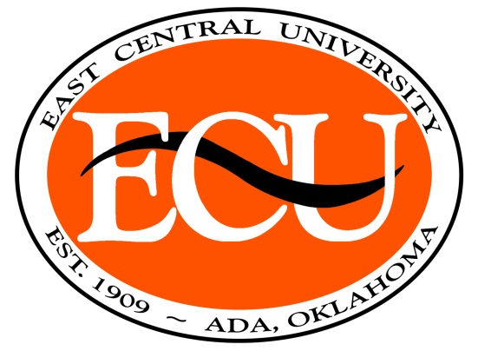

Communication & Performance Studies Program
Scholarship Application Form
Spring 2019

Name ____________________________________________ECU ID _________ Date _________________
Address __________________________________________City, State and Zip________________________ Phone ________________________ Email ____________________ Major ___________________________
2nd Major or Minor _______________GPA (Incoming use previous college or high school GPA) ______
Classification ____ Incoming ___ Transfer ____Freshman ___ Sophomore ___ Junior ___ Senior
(Transfer students should check that box and classification based on hours transferred)
I am interested in the following scholarships (check all for which you meet eligibility requirements):
____ Briles Scholarship (2.5 gpa or above, based on need, incoming students may apply)
____ Elizabeth Blakesley Scholarship (3.0 gpa or above, major concentration in theatre, music theatre, minor in dance, or minor in theatre, Incoming students may apply.)
____ Finis Morrison Scholarship (3.0 gpa or above, major concentration in theatre, music theatre, minor in dance, or minor in theatre, Incoming students may apply.)
____ Coleman Communication Studies Scholarship (2.5 or above, awarded to outstanding junior or senior majoring in Communication Studies)
____ Higginbotham Family Scholarship (3.25 gpa, Junior or Senior major or minor in Communication & Performance Studies concentration)
____ Dorothy I. Summers Scholarship (2.5 gpa, theatre, music theatre, speech teacher certification majors, dance or theatre minors, Must be some evidence of volunteer technical work on productions, Incoming students may apply.)
____ Linscheid/Nabors Speech Award (2.5 gpa, students planning a profession in which public speaking will be used extensively, students planning to enter the teaching profession, or students who excel in forensic competition)
____ Lee Blaney Drama Award (Outstanding Theatre Major)
____ Tuition Waiver (2.5 gpa or above, Oklahoma resident, major or minor in Communication & Performance Studies degree program, fewer than 124 hours of college credit, enrolled for 12 or more hours in semester for which awarded. Incoming students may apply.)
____ Musical Theatre Waiver (2.5 gpa or above, Oklahoma resident, major in Musical Theatre or involved in Showtime, fewer than 124 hours of college credit, enrolled for 12 or more hours in semester for which awarded. Incoming students may apply.)
____ Forensics/Debate Waiver(2.5 gpa or above, Oklahoma resident, major in Musical Theatre or involved in Showtime, fewer than 124 hours of college credit, enrolled for 12 or more hours in semester for which awarded. Incoming students may apply.)
If you are uncertain of your qualification, check the box and explain on the other side.
Additional scholarships may be available through the ECU Foundation. Please check their website for scholarships for which you may be eligible. Non-traditional female students are urged to look at the ECU Women’s Club and Martha Eubank/Wallace Rhynes Scholarships to see if they qualify.
For Theatre, Music Theatre, and Speech Teacher Certification Concentration Majors and Theatre minors, scholarships are given based on past participation but with the expectation of continued participation both onstage and offstage. Accepting a scholarship or waiver requires that you agree to work on a stage crew for one of the two ECU Theatre productions in the semester for which you received the award (exempt when taking COMM 2241 Intercollegiate Forensics). Those cast in both shows may do so by putting in 25 shop hours or another assignment agreed to by the Director of Theatre. Failure to do so will result in disqualification from receiving scholarships or waivers for the following semester. Please acknowledge your understanding by signing in the space below. Student Signature____________________________________

Please fill out the following to the best of your ability with experience from the past 12 months.
Incoming and transfer students may use high school or previous college activities.

Performance Related Activities – Performance/Directing

Performance Related Activities – Technical (indicate when & where you put in hours for scholarships or waivers received Fall 2018)

Speech/Forensics/Debate Activities

Honors/Awards/Memberships

Statement of Need (optional unless applying for the Briles Scholarship)

High School and Transfer students may submit a letter of recommendation from previous faculty regarding their previous work. Due by Monday, Nov. 5, 2018 at 11:30 am to Dr. Phillips, Dr. Groetzinger, or Janet Alexander in room 134.

