**NASNTI Funded Research Projects**

**Spring 2019**

**Emily Angell “Mired in Red Tape: Invoking and Overcoming Stereotypes of Native Americans in *Longmire*”**

Emily worked as a research apprentice for Dr. Jennifer McMahon collecting data for an essay that had been selected for publication. In her work, Emily watched every episode of the tv show *Longmire* and examined all instances Native American representation in the show.

**Socorra Rider “A Short Story from a Chickasaw Native”**

Socorra worked under the direction of faculty mentor Dr. Robin Murphy to research several aspects of Native American Storytelling including common traits among traditional stories and storytellers, the role of women’s voices in traditional storytelling, and how culture and heritage is employed in traditional stories.

<https://youtu.be/v4H0BjRYOOI>

**Amber Deela “Critical Approaches to Gender: Contemporary Critical Readings”**

Amber worked under the direction of faculty mentor Dr. Rebecca Nicholson Weir to critically examine several novels using Feminist Theory, Gender Theory, Embodiment Theory, and Essentialism and developed a personal definition of feminism, gender dynamics, and androgyny.

**Brandy Frazier “Artistic Obsessive Ritual Methods”**

Brandy worked with faculty mentor Dr. Robin Murphy to learn how to use obsessive rituals and repetition and demonstrate these methods in a piece of original artwork. Brandy utilized several ECU resources provided by the Linscheid Library and the Art Department to research the topic including art catalogues, books, and online research tools.

<https://youtu.be/KVuWhaykM2o>

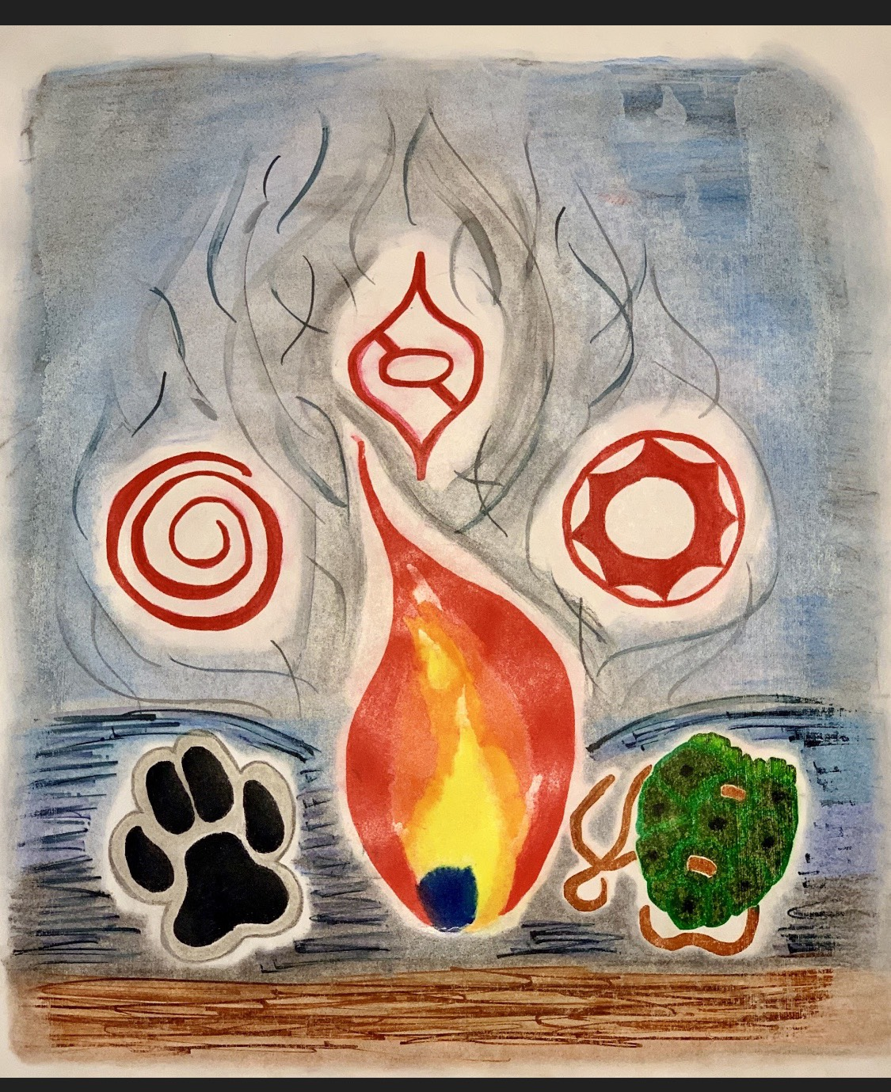 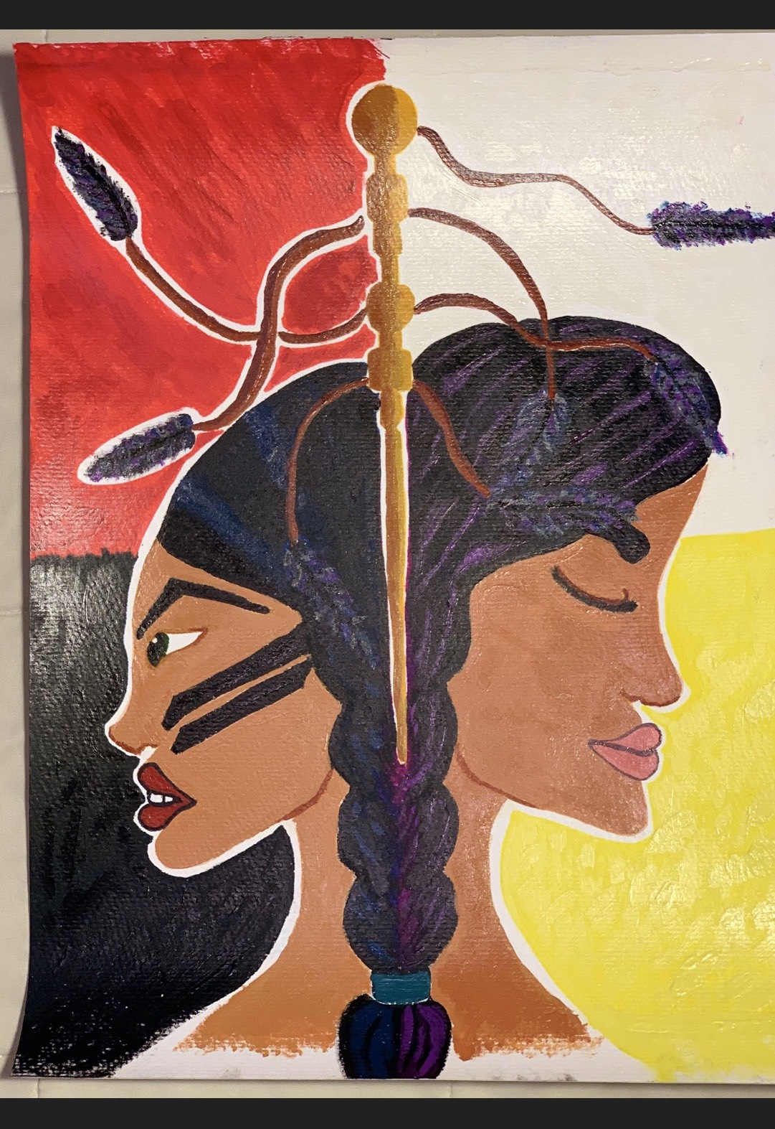 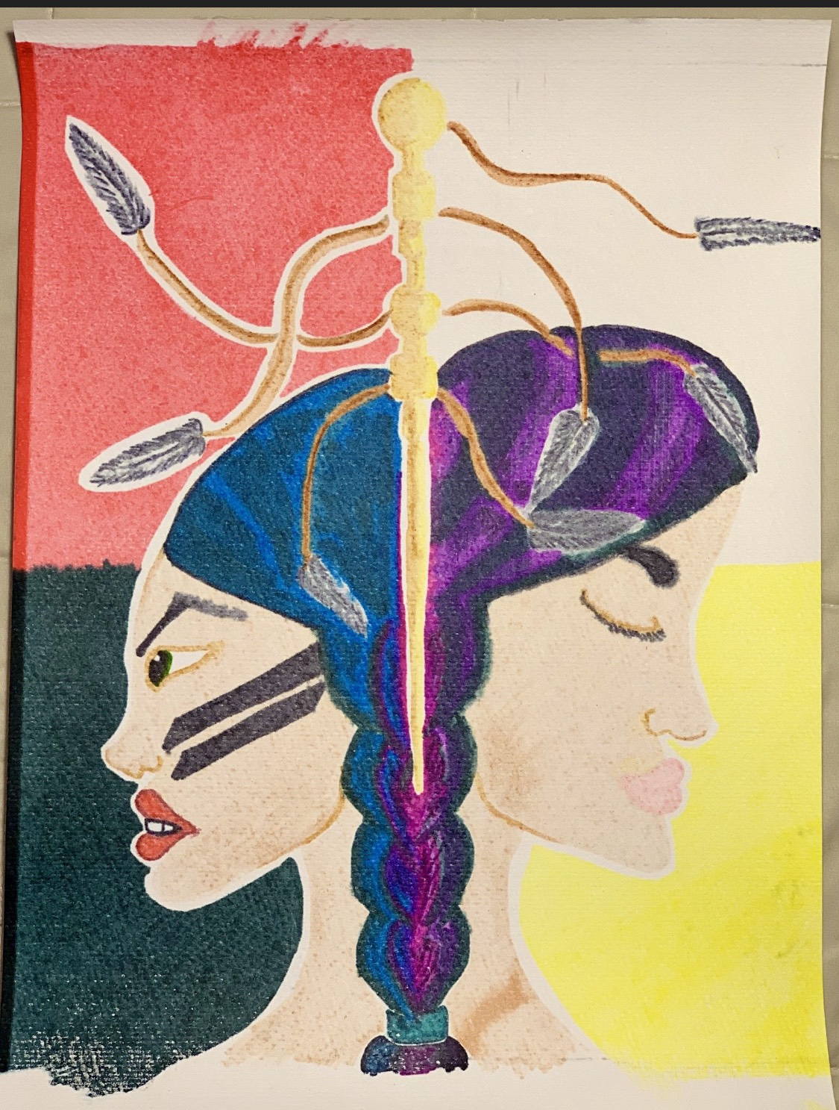

**Sharayah Alkire “*The Originals* Digitization Project”**

Sharayah worked under the supervision of Dr. Robin Murphy as a research apprentice to digitize of ECU’s student literary magazine *The Originals* using the book scanner available in the Linscheid Library’s Digital Humanities Lab. This project required learning how to use software and hardware used in the project, knowledge of archival practices, and demonstrate skill in copyright research.

**Jacob Riddle “Tribal Support for Public Services in Oklahoma”**

Jacob worked as a research apprentice for Dr. Christine Pappas gathering information from tribal websites and public information about how Native American tribes financially support public services such as roads and schools. The research was used to revise Dr. Pappas’ book chapter entitled “Modern Sequoyah: Native American Power in Oklahoma Politics”.

**Bryce Clark “Healthy Ad Campaign”**

Bryce worked with Dr. Zhaohui Su to execute a Health and Wellness campaign targeting Native Americans. He researched important information to share with his target audience, wrote catchphrases, and worked as a mass media creator to design approachable displays of healthy facts focused on healthy eating and physical activity.

**Justyne Eden “Advertisements for Suicide Prevention”**

Justyne worked with Dr. Zhaohui Su to create a series of health advertisements focusing on mental health and suicide prevention. These ads consisted of 3 videos of different age groups each with their own unique story about how a suicide prevention line saved their lives. Each story is relatable to the age group they are supposed to be targeting. During this process she created the script, found the models, set up the equipment, recorded, and edited all the videos.

**Fall 2019**

**Kara Hodo “*The Originals* Digitization Project”**

Kara worked under the supervision of Dr. Robin Murphy as a research apprentice to continue the digitization of ECU’s student literary magazine *The Originals* using the book scanner available in the Linscheid Library’s Digital Humanities Lab. This project required learning how to use software and hardware used in the project, knowledge of archival practices, and demonstrate skill in copyright research.

<https://linscheidlibrary.wixsite.com/ecuoriginals/archive>

**Emily Angell “Storytelling as Revolt”**

Emily worked under the supervision of Dr. Jennifer McMahon to examine how storytelling relates to philosophical concepts such as Camu’s concept of the absurd. In her analysis, she looked at elements of the absurd such as revolt as a lens in which to understand the living history that is storytelling.

**Briana Mason “Chickasaw QR Codes”**

Briana worked under the supervision of NASNTI’s Research and Language Specialist, Amy Lyons-Ketchum, to complete a Language Revitalization themed Service Learning project. This project involved collecting and recording linguistic data in the form of common classroom vocabulary from ECU’s Chickasaw Language instructor. Briana then used professional sound editing software to edit the sound files and link them to QR codes that were placed throughout ECU’s campus. Students, faculty and staff could then scan the QR codes to hear the Chickasaw vocabulary. This project was practical experience in the field of Language Revitalization and also serves to advertise the Chickasaw Language classes offered at ECU.

**Spring 2020**

**Megan Bucktrot "ECU Resource Guide"**

Megan worked with the NASNTI HERITAGE Program's Retention Specialist Dana Jordan to create a useful resource guide for ECU students, faculty, and staff. It provides important information about ECU's different offices and departments and the services they provide. The guide is available in both a digital and printed booklet format.

**Sydney Abbott “Water as a Cultural Resource”**

Sydney worked as a research apprentice to Dr. Terrie Becerra on the “Water as a Cultural Resource” Project. In this role she helped to complete a literature review and prepare data for analysis. As a Chickasaw citizen, Sydney was excited to learn more about her heritage and the important role water plays not only for drinking and bathing but for cultural ceremonies as well. Sydney was able to improve her Excel skills through this project and gain a better appreciation for her ability to overcome new challenges.

**Melanie Andrews “Freedmen Band of Oklahoma”**

Melanie researched the Freedman Band Indians, former slaves that fought alongside the Seminoles in Florida during the Seminole War, and the complicated legacy of the blood quantum requirement for Seminole people. She interviewed elders from her tribe to determine their opinions of the blood quantum requirement and the citizenship status of the Freedmen.

**Karlie Ryal “Choctaw Flashcards and Glossary”**

Karlie worked under the supervision of NASNTI’s Research and Language Specialist, Amy Lyons-Ketchum, to complete a Language Revitalization themed Service Learning project. This project involved collecting and recording linguistic data in the form of level 1 vocabulary from ECU’s Choctaw Language instructor. Karlie then edited the audio files and gathered corresponding photos. The audio and image files were then used to create audio-visual flashcards that Choctaw language learners at ECU can use to study the language. The same audio-visual files were then used to create a glossary using the FLEx software from SIL International.

**Jessica Wakefield “Ethnohistory and Archaeology of the Canadian River in Pontotoc, Hughes, and McClain Counties, Oklahoma”**

Jessica worked as a research apprentice to Dr. Holly Jones on the “Ethnohistory and Archaeology of the Canadian River in Pontotoc, Hughes, and McClain Counties, Oklahoma” project. In this role, Jessica researched, copied, and downloaded documents with useful information regarding the citizens, early schools, stores, and events leading to the abandonment of Tyrola and relocation of Newton. In addition, Jessica compiled relevant information on railroads and bridge crossings in the study area. The document types collected during this initial phase of the multi-year research project include newspaper articles and advertisements, school records, post office records, census data, obituaries, and photographs.

**Dawsyn Lyon “Does Participation in Athletics Impact Students’ Academics?”**

Dawsyn researched the affect participation in sports has on a student’s academics. Dawsyn found that “student athletes frequently say the hardest part about being a student athlete in college or in high school is knowing how to manage your time wisely.” She also makes the point that athletic scholarships have brought in so many more students that more than likely would never had even thought they had a chance at going to college. While playing sports does affect students’ GPA, it also has many positive benefits.

**Kara Hodo “African American Identity in the Early Life and Works of Langston Hughes”**

Kara’s research focused on the pioneering 20th century African American writer and poet Langston Hughes. She did a close-reading of one of Hughes’ lesser-known poems “Angels Wings.” This poem takes a tragic look at an African American who feels ashamed of his racial identity, and it gave Kara the idea of doing research to learn more about Langston Hughes and his strong sense of African American identity.

**Dream Greene “General Practice in Healthcare”**

Dream completed a General Practice in Healthcare through his Social Work class for his NASNTI funded research project. For this project, Dream consistently found himself back in the classroom or a mock interview while on site. He would look back to what he learned from his classmates, NASW Code of Ethics, readings and much more of what experiences obtained back on campus to guide him through uncertain times. According to Dream, “This internship is one of the best things my education has brought to me thus far.”