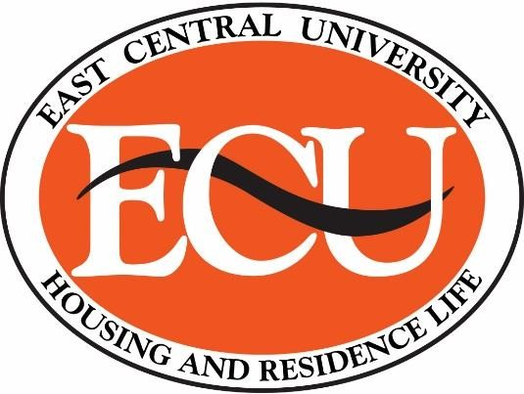 **ECU Housing & Residence Life**

**1100 E. 14th St**

**PMB: R-7**

**Ada, OK 74820**

**(580) 559-5602**

2022-2023 Room & Meal Plan Rates

**Room Rates:**

|  |  |
| --- | --- |
| Chokka-Chaffa' Double | $1,875/Semester |
| Pesagi Double | $1,150/Semester |
| Pesagi Single with private bath | $1,825/Semester |
| Pontotoc Double | $1,225/Semester |
| Pontotoc Single with shared bath | $1,800/Semester |
| Pontotoc Single with private bath | $1,900/Semester |
| Tiger Commons 2 Bdrm | $2,725/Semester |
| Tiger Commons 4 Bdrm | $2,475/Semester |
| Stadium Apts. 2 Bdrm | $2,475/Semester |
| Animal Friendly Housing  **Meal Plan Rates:** | $2,625/Semester |
| 10 Meals Per Week | $1,489/Semester |
| 14 Meals Per Week | $1,658/Semester |
| 19 Meals per Week | $1,808/Semester |
| Flex Plan* | $950/Semester |
|  |  |

*Flex Plan ONLY available for Tiger Commons, Animal Friendly, Stadium Apartments and commuting students.

** The Flex plan costs $950 per semester and allows the student to spend $900 at the Taff Cafeteria, the University Center Snack Bar, and the CBCC Snack Bar.  Why is there a $50 upcharge on the plan?   The upcharge covers base operational expenses that the University incurs to create multiple flexible convenient food options on campus.  The Flex plan allows purchasing without tax (which in Ada is 9.38%) which results in a net savings to students.