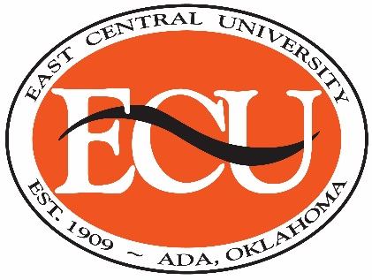

**PUBLIC NOTICE OF UPCOMING ACCREDITATION REVIEW**

**BY THE ACEN**

The East Central University School of Nursing wishes to announce that it will host a re-accreditation site visit for its Bachelor of Science in Nursing program by the Accreditation Commission for Education in Nursing (ACEN),

You are invited to meet the site team and share your comments about the program via a Zoom meeting to be held on April 5, 2022 at 2:30pm CST.

Join Zoom Meeting  
<https://zoom.us/j/96028933518?pwd=QjBWZVRnanEzNGdtWFdzUk0rb2p5QT09>  
Meeting ID: 960 2893 3518  
Passcode: 229830

One tap mobile  
+12532158782,,96028933518# US (Tacoma)  
+13462487799,,96028933518# US (Houston)  
Dial by your location  
        +1 253 215 8782 US (Tacoma)  
        +1 346 248 7799 US (Houston)  
        +1 669 900 6833 US (San Jose)  
        +1 301 715 8592 US (Washington DC)  
        +1 312 626 6799 US (Chicago)  
        +1 929 436 2866 US (New York)  
Meeting ID: 960 2893 3518  
Find your local number: <https://zoom.us/u/ac299w35EZ>

Written comments are also welcome and should be submitted directly to:

Dr. Marsha Stoll, Chief Executive Officer

Accreditation Commission for Education in Nursing

3390 Peachtree Road NE, Suite 1400

Atlanta, GA 30326

Or email: [mstoll@acenursing.org](mailto:mstoll@acenursing.org)

All comments should be received by the ACEN by March 23, 2022

**SCHOOL OF NURSING**

**1100 E. 14TH STREET, PMB V-8 • ADA, OK 74820**

**580-559-5434 • FAX: 580-559-5785 • www.ecok.edu/nursing**