**REFUNDS ARE PROCESSED THROUGH TOUCHNET!!!**

**TouchNet**: Where students pay their bill online, setup student payment plans, setup authorized users, and receive refunds via direct deposit or paper check.

The procedure to access **TouchNet**:

1. Go to the ECU website: ecok.edu
2. Click on “Login” at the top of the screen
3. Click on “Colleague Self-Service”
4. Click on the “Colleague Self-Service Login” orange button
   1. It is above the “Student Tutorial” video
5. Login with your username and password
6. On the home screen of Colleague Self-Service, click “Student Finance”
7. Click “Make a Payment”
8. Click “Continue to Payment Center”
9. Login with your ECU Outlook email address
   1. Make sure that you are using Google Chrome
10. On the home screen of TouchNet you will see “Make Payment, Payment Plans, Refunds, etc.”
    1. You should see this window pop-up **if you have not** setup your refund method yet
11. 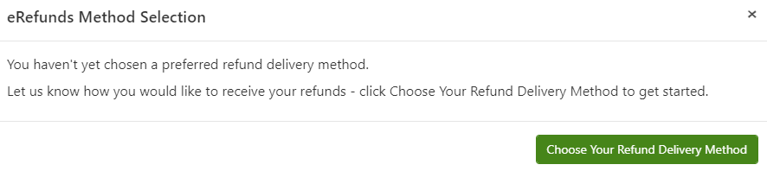
12. Click on “Refunds” at the top or “Electronic Refunds” to setup your refund method **IF** you **DO NOT** see the window above
13. Click “Choose Your Refund Delivery Method” and “Heartland ECSI” should open up in a new tab
14. Click “Select”
15. Enter your account type, bank’s routing & account number, and account holder name
16. Click “Continue”
17. Agree to terms & conditions and YOU ARE DONE!!
18. We encourage students to setup their direct deposit AS SOON AS POSSIBLE (ASAP) before refunds are issued